Features of Victorian Architecture and Interiors
The Victorian Period (1837-1901) was known for its eclecticism. There were revivalist styles (Romanesque, Gothic, Renaissance/Italianate, Neo-Grec, Classical Revival) and “composite” styles that combined several trends which resulted from the abundance of new approaches to design, new textiles, and other products resulting from the Industrial Revolution. Several reform styles (which reacted against this eclecticism and materialism) do fall within this time period but are not covered in this hand-out. This hand-out focuses on the typical, “composite” Victorian style.
Typical interiors of a Victorian middle to upper-class home included:

- Lots of fabric and upholstery: Overstuffed chairs, tufted ottomans, window treatments of several layers including heavy outer curtains and thick lace

- A patterned carpet

- A wide range of surface decoration, from inlaid and carved wood to marble tops.

- Bronze statues, marble figures – often classical (Greco-Roman) or “exotic” from colonial territories (esp. India or Turkey)

- Finials, carved or cast iron, decorative knobs or points attached to the ends of balustrades, stairwells, etc

- Elaborate fireplaces

- Carved sideboards

- Potted plants

ARCHITECTURE

As mentioned above, the Victorian Period (1837-1901) was known for its eclecticism. There were revivalist styles (Romanesque, Gothic, Renaissance/Italianate, Neo-Grec, Classical Revival). More inventive architectural designs included Eastlake, Stick, Queen Anne, and others, the styles of which were freely combined, resulting in buildings which are difficult to categorize and can be termed simply “Victorian” or “Victorian Composite.”

Victorian or Victorian Composite architecture often included:

Brackets
Of machine-carved wood or cast iron. Often scrolls or fans. Often structurally unnecessary although they seem to be attaching elements, e.g. the walls of the porch to the roof of the porch.

Cupola

Bay Window
A window that juts out of a house; it can have 1-3 windows.

Decorative features, usually elaborate, often structurally unnecessary.

Dentils
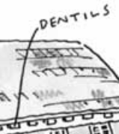 A molding with rectangular features that runs along a house.

Columns

Clapboard siding

Cornice
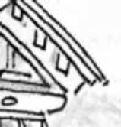 A band that runs along the area where the roof and wall meet. Can be plain or carved.

Dormer
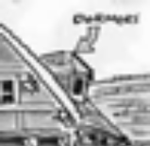 A window that juts out from the roof and which has its own roof.

Finials
Decorative knobs or points attached to the tops of turrets, towers, roof peaks.

Gable
The triangular part at the end of a building formed by the two sides of a sloping roof.

Gazebo
A separate roofed, but open-air structure that often mimicked the architecture of the main house.

Lathe-shaped wooden forms:
Porch posts, railings, balustrades, bargeboards, braces and pendants. Worked or turned on a mechanical lathe, giving the appearance of the heavy legged furniture of the period.

Lintel
A post that goes across the top of a window or door.

Mansard roof
A roof with two slopes; often it is flat on top.

Mechanical jigsaw wooden forms:
Large curved brackets, scrolls, and other stylized elements often are placed at every corner, turn, or projection along the facade.

Metal grillwork
Often in cast iron.

Pediment
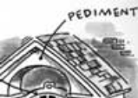 The triangular area on the front of a house; it often extends from the roof to cover the porch.

Porches
On front of house (fresh air was very important to the Victorians).
Portico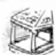
A porch with a roof.

Transom 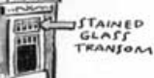
A window or panel, usually operable, above a window or door.

Turret
A short, narrow tower, usually at the corner of a building.

Windows
Were often a variety of shapes (see bay window), including round.

Eastlake Style

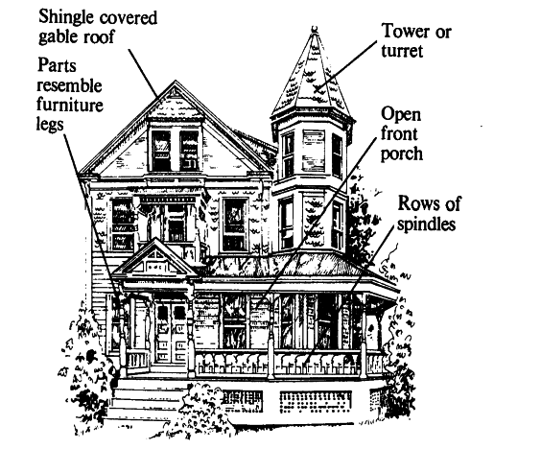

Eastlake-Stick Victorian House

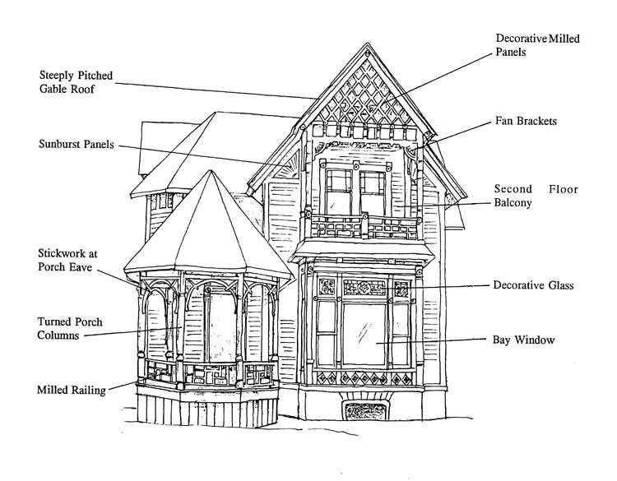

High Victorian Italianate Style

