Victorian Interior Design and Architecture
The Victorian Period (1837-1901) was known for its eclecticism and its proliferation of goods, forms, and styles that were the result of new industrial processes, new textiles, and other products resulting from the Industrial Revolution. Other factors that led to the boom in products and building were: the increase in urbanism, changes in retail and catalogue shopping, increased marketing, and a stronger purchasing power of the middle class.

INTERIORS

Victorian interior design can be “read” for issues of:
- Industrial Revolution (Which new processes/products/designs/materials can be seen?)
- Class and the display of wealth/status (How is wealth/status displayed and how are distinctions between the classes blurred or defined?)
- Gender (the private, interior, feminine domestic sphere vs. the public, exterior, masculine sphere)
- Politics/culture/race (What does a display of “The Exotic” tell us?)
- Relationship with the outside world (How is the outside world invited in or held at bay?)
- Relationship with nature and the city (How is nature seen or not seen? How is a sophisticated, cultured, urban – or worldly - context revealed or concealed?)

Typical interiors of a Victorian middle to upper-class home included:

- Lots of fabric and upholstery: overstuffed chairs, tufted ottomans, window treatments of several layers including heavy outer curtains and thick lace

- A patterned carpet

- A wide range of surface decoration, from inlaid and carved wood to marble tops.

- A wide range of materials, from cast iron to marble.

- Bronze statues, marble figures – often classical (Greco-Roman) or “exotic” from colonial territories (esp. India or Turkey).

- Other “exotic” elements, often referred to generally as “Persian” or “Oriental.”

- Objects in revivalist styles: Gothic Revival, Renaissance Revival, Greek Revival (Neo-classical), and Egyptian Revival.

- Finials, carved or cast iron, decorative knobs or points attached to the ends of balustrades, stairwells, etc.

- Elaborate fireplaces –the heart of the home

- Carved sideboards or book cases, often immense in size, displaying objets d’art (art objects) or mementos/souvenirs of travel

- Paintings, prints (and, later, photographs) in ornate, gilded (or faux-gilded) frames.

- Potted plants

- Color:
Deep, warm and/or subdued color tones, often used to emphasize the importance of a room. In more urban areas, colors like gray, darker green, and a grayer blue were often chosen to minimize the effect of grime and soot from coal dust and stains from gas and oil lamps.

- Pattern:
Patterns covered wallpapers, fabrics, rugs, decorative objects, etc.

ARCHITECTURE
There were revivalist styles (Romanesque, Gothic, Renaissance/Italianate, Neo-Grec, Classical Revival).

Newer architectural designs included Eastlake, Stick, Queen Anne, and others, the styles of which were freely combined, resulting in buildings which are difficult to categorize and can be termed simply “Victorian” or “Victorian Composite.”

Several reform styles (which reacted against this eclecticism and materialism e.g. The Arts and Crafts Movement) do fall within this time period but are not covered in this hand-out. This hand-out focuses on the typical, “composite” Victorian style.

Victorian or Victorian Composite architecture often included:

Brackets
Machine-carved wood or cast iron. Often scrolls or fans. Often structurally unnecessary although they seem to be attaching elements, e.g. the walls of the porch to the roof of the porch.

Cupola

Bay Window
A window that juts out of a house; it can have 1-3 windows.

Decorative features, usually elaborate, often structurally unnecessary.

Dentils
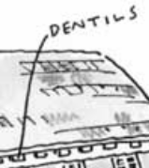 A molding with rectangular features that runs along a house.

Columns

Clapboard siding

Cornice
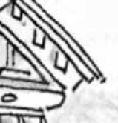 A band that runs along the area where the roof and wall meet. Can be plain or carved.

Dormer
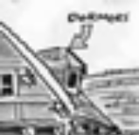 A window that juts out from the roof and which has its own roof.

Finials
Decorative knobs or points attached to the tops of turrets, towers, roof peaks.

Gable
The triangular part at the end of a building formed by the two sides of a sloping roof.

Gazebo
A separate roofed, but open-air structure that often mimicked the architecture of the main house.

Lathe-shaped wooden forms:
Porch posts, railings, balustrades, bargeboards, braces and pendants. Worked or turned on a mechanical lathe, giving the appearance of the heavy legged furniture of the period.

Lintel
A post that goes across the top of a window or door.

Mansard roof
A roof with two slopes; often it is flat on top.

Mechanical jigsaw wooden forms:
Large curved brackets, scrolls, and other stylized elements often are placed at every corner, turn, or projection along the facade.

Metal grillwork
Often in cast iron.

Pediment
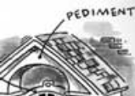 The triangular area on the front of a house; it often extends from the roof to cover the porch.

Porches
On front of house (fresh air was very important to the Victorians).
Portico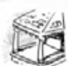
A porch with a roof.

Transom 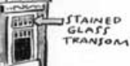
A window or panel, usually operable, above a window or door.

Turret
A short, narrow tower, usually at the corner of a building.

Windows
Were often a variety of shapes (see bay window), including round.

Eastlake Style

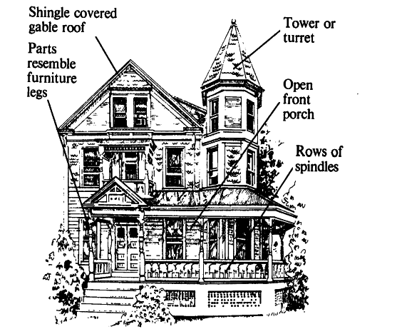

Eastlake-Stick Victorian House

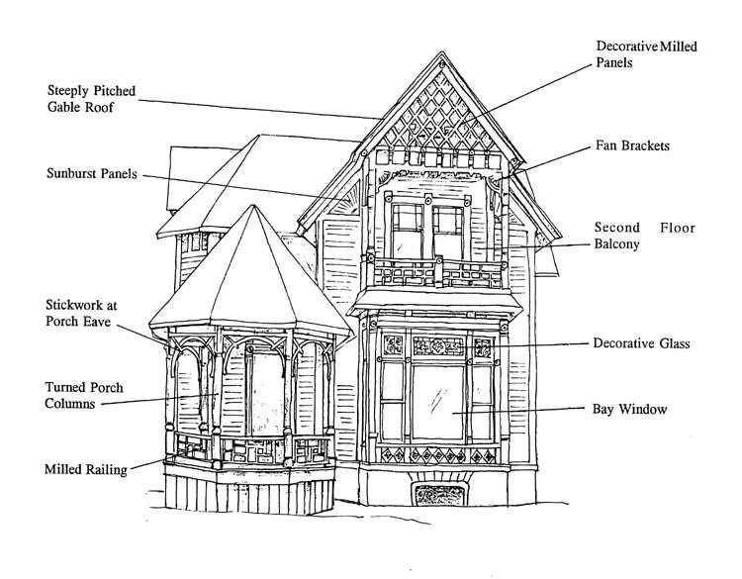

High Victorian Italianate Style

