History of Design
Instructor: Gayle Clemans

Extra Credit
Architecture Observation Journal
Due: by the last day of class

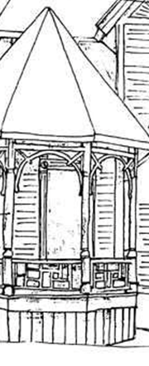
Seattle has some wonderful buildings, many of which were built during the time span of this course (1850s-1960s). Keep an eye out for buildings — or details of buildings — that remind you of material covered in this class: Styles, cultural forces, technical developments, terms and concepts, etc.
Consider taking an architectural tour (totally optional). The Seattle Architecture Foundation offers some great ones, with excellent, accurate information. http://seattlearchitecture.org/tours_month.html
Turn in a “journal” with twenty entries — sketches and notes — based on historical architectural elements that you see around Seattle.
Imagined questions from a student. Answers from the instructor.
Does it have to be an actual journal? No. It can be twenty separate sheets of paper stapled together.
How detailed do the sketches need Detailed enough so that it’s clear you spent time really looking.
to be?

What if I can’t draw? No problem! You still need to include sketches, but they can look terrible. For this “assignment,” the process of looking and recording what you see is more important than the quality of the product. You can receive full credit with very little ability to render things realistically. But you must try.
Can it include a more recent building? Well, yes, actually. We will BRIEFLY cover postmodern architecture on the last day, and this journal is due on that very day, so you would be on your own when it comes to including notes about anything later than the 1960s.
Each entry must include:
- Location of building (street address or approximate address e.g. “Corner of Smith and Pine, Downtown”)

- A fairly detailed sketch of the building and/or the architectural detail you’ve noticed.

- At least 3 notes about the item sketched.

Your notes can be simple statements or complex phrases. You do not need to write a paragraph for each note.

Consider the following questions when looking at your example (or looking at your sketch):
What style(s) does it remind you of?
Why did this style develop?
Which cultural forces might have been at play?
Does it remind you of any architect or building from lecture or your textbook?
Can you apply any terms or concepts from class?
What about technical developments?

If you’ve chosen a detail, you can also consider:
Why that detail?
How does the part (detail) relate to the whole? Is it particularly emblematic of a style?

