Women as Artists
Women as Artists Instructor: Gayle Clemans
READING: Christopher Knight, “In Wonderland: Surrealist Adventures of Women Artists,” 2012
http://latimesblogs.latimes.com/culturemonster/2012/01/art-review-in-wonderland-surrealist-adventures-of-women-artists-at-lacma.html
With all of your extra readings, please print them out and actively read them. Mark them up, circle and underline words, and make notes in the margins. Bring the assigned reading to class, along with your written responses to the questions below, and be prepared to participate in a discussion.
Your written responses serve two purposes:
• They show me that you’ve done the reading and were engaged in the material.
• They are YOUR notes and should be useful to YOU as prompts for discussion.
(Therefore, you can use bullet points, phrases, quotes – whatever is useful to you. They do not need to be typed. They do not need to total more than a page.)

BACKGROUND ON THE READING. This is a straightforward review of an exhibition about women Surrealists in the United States and Mexico. I chose it as preparation for our viewing of the Frida Kahlo movie because it puts Kahlo’s work – and life story – into a larger context. It also serves as a quick introduction to some of the gendered issues within the Surrealist movement.

QUESTIONS:
- In several places throughout his review, critic Christopher Knight lays out the typical understanding of Surrealism – its goals, key figures, and when and where it took place. Jot down some notes about where/when/why Surrealism took place, according to this typical understanding.

- How does this exhibition “compellingly explode” or expand upon that typical understanding of Surrealism?

- Within this typical version of Surrealism, what was the attitude toward women? What did André Breton suggest in his second Surrealist manifesto?

- What did Surrealism — particularly in the U.S. and Mexico — offer to women artists? Why was it appealing?

- Generally speaking, what were some themes or strategies that appear in the work of female Surrealists? Hint: these are sprinkled throughout the article and listed in a description of the thematic organization of the galleries.

- Write down some notes about Frida Kahlo’s work. What are some themes or sources of inspiration? What does Knight suggest about her talent for self-mythologizing?

Art review: 'In Wonderland: Surrealist Adventures of Women Artists' at LACMA
January 30, 2012

Probably the most famous of all Surrealist paintings is Salvador Dalí's weird little 1931 canvas, "The Persistence of Memory." Dating from the European movement's heyday between the First and Second World War, when Surrealism's psychic, sociocultural probings dominated the School of Paris, its soft, drooping pocket-watches scattered around a barren landscape create an unforgettable image of the pliability of time and space.

An unexpected twist on that theme emerges from an engrossing new show at the Los Angeles County Museum of Art. Revising Dalí, call it "the persistence of Surrealism."

All of the more than 170 paintings, sculptures, photographs and prints were made by artists working in North America -- not in France, but in the U.S. and Mexico. Barely three dozen works date from the 1920s and 1930s, when André Breton, the so-called Surrealist Pope, was busy authorizing doctrine and offering blessings and excommunications. (Jacqueline Lamba, once Breton's wife, is among the 47 artists.) More than a quarter were instead made between 1950 and the 1970s.

In those decades Abstract Expressionism, Neo-Dada, Pop art, Minimalism and other forms came to the forefront. Surrealism had by then largely moved into museums -- the storerooms of establishment history. Surrealism was an exemplar of the disorienting stresses of modern life in the tumultuous years between two cataclysmic wars, its embrace of illogical imagery a stinging critique of supposedly rational European society belied by brutal chaos.

Except, not quite. "In Wonderland: The Surrealist Adventures of Women Artists in Mexico and the United States" compellingly explodes the tale.
The key to understanding how comes in the lengthy title's seventh word. Women, needless to say, were not representative of the establishment, artistic or otherwise, in the '20s and '30s.

Tanning BIRTHDAY2In 1927 Breton's second Surrealist manifesto embodied the general sexism of the day. He extolled women as the muses of men, who were assumed to be the important artists. Presumably male creativity required a boost from innate feminine fecundity.

"The problem of woman is the most marvelous and disturbing problem in all the world," Breton once said -- the problem plainly being his. Sigmund Freud had famously asked, "What do women want?" Breton blithely figured that what they wanted was forever to be cast in the outlier role of "other."

"In Wonderland" begins -- well, in wonderland, otherwise known as Hollywood.

Clips of "Meshes of the Afternoon," an experimental 1943 film shot in the Hollywood Hills by Maya Deren and her cinematographer husband, Alexander Hammid, present a dream-like chase after a mysterious hooded figure with a mirror for a face. Paintings from 1951 and 1943 in the next room by Alice Rahon, wife of Surrealist artist Wolfgang Paalen, a Viennese emigre to Mexico, and Sylvia Fein, who lives and works in Milwaukee, use Lewis Carroll's Alice-down-the-rabbit-hole for their own alienated adventures into literary-minded nonsense.

The most riveting picture in the introductory gallery is Dorothea Tanning's "Birthday" (1942), a hyper-realist self-portrait. The artist, semi-dressed in a Renaissance blouse and a skirt of driftwood teeming with tiny bodies, stands at the entrance to a labyrinth of doorways. She's a beautiful sorceress accompanied by a mythical creature called a basilisk, which could kill with just a puff of its poison breath. Tanning seems capable of accomplishing the same with just a glance.

"Birthday" is an image of awakening power. As such it heralds perhaps the most interesting aspect of the show: "In Wonderland" proposes that, unlike dusty Europe, the New World held promises of self-reinvention. For Surrealist women, the artistic possibilities were especially rich.

Women certainly began to explore Surrealist themes in the '20s and '30s. Helen Lundeberg's shadowy, double self-portrait shows the child as mother of the imagined woman. Lee Miller's grim photographs serve up a woman's severed breast on a dinner plate. Lola Alvarez Bravo photographed a broken sculpture lying in a field of rubble like an entire culture's maimed body.

Frida Kahlo's monumental, double self-portrait invokes her German and Mexican ancestry in mirrored images of a European woman and a Tehuana Indian holding hands. It also transforms a traditional Mexican wedding portrait. Painted at the time of her stormy divorce from Diego Rivera, she pictures an unorthodox determination to marry herself.

Lundeberg DOUBLE PORTRAIT OF THE ARTIST IN TIME2But Surrealism was partly exported across the Atlantic by artists fleeing Hitler. Its North American reception takes a variety of forms. Mexico's mysticism, inflected by Pre-Columbian and Catholic cultures, is very different from the Protestant roots of American puritanism and practicality.

Remedios Varo, born in Spain and exiled in Mexico City, developed an exquisite fragility in painterly style, building up layers of tiny, egg-tempera-like brushstrokes that transmit her androgynous figures' sense of dreamy vulnerability. By contrast, Chicagoan Gertrude Abercrombie, although formally trained, painted with a plainspoken bluntness reminiscent of folk art. Her figures, often iconic, exude a crazy charm, as if portraits of the neighborhood eccentric.

Both artists jam a stick into the spinning wheels of ordinary life. But the results couldn't be more different.

The exhibition was organized by LACMA curator Ilene Susan Fort and Tere Arcq of Mexico City's Museum of Modern Art, where it travels next fall, following a stop at Canada's National Museum of Fine Arts in Québec. It's installed thematically, rather than chronologically. Irregular freestanding walls are linked by zigzag lengths of rope, plainly meant to evoke Marcel Duchamp's 1942 exhibition design for Breton's "First Papers of Surrealism." Duchamp, with a tangled web of what he claimed was 16 miles of string obstructing passage, blocked visitor access to the assembled art; LACMA viewers won't have similar trouble.

Interestingly, the contingent of abstract Surrealists is small; figurative art dominates. Galleries look at portraiture, creativity, domesticity, Surrealist games and more. Some of the 47 artists are little-known, like ex-pat Hungarian photographer Kati Horna and Chicago watercolorist Julia Thecla. The show peters out a bit at the end, where a turn to chronology considers the 1960s feminist revolution and beyond. Feminism's successes may have rendered superfluous the style's influential assault on bourgeois norms.

The show's sprawling size provides a welcome artistic context for Kahlo, one of the 20th century's most famous painters, who's well-represented here. Among her seven paintings are the great narrative of New York socialite Dorothy Hale's suicide from a skyscraper leap, rendered in the manner of a traditional Mexican ex voto humbly seeking forgiveness, plus a beautiful self-portrait draped in a bloody necklace of thorns. A canny Kahlo strategy was self-mythologizing, perhaps picked up from Communist propaganda images that, from Lenin to Mao, always extol fearless revolutionary leaders in pictures. Accompanied by so many Surrealist women, Kahlo can be appreciated for her work, rather than for her singular biography.

-- Christopher Knight

Los Angeles County Museum of Art, 5905 Wilshire Blvd., (323) 857-6000, through May 6. Closed Wednesday. www.lacma.org

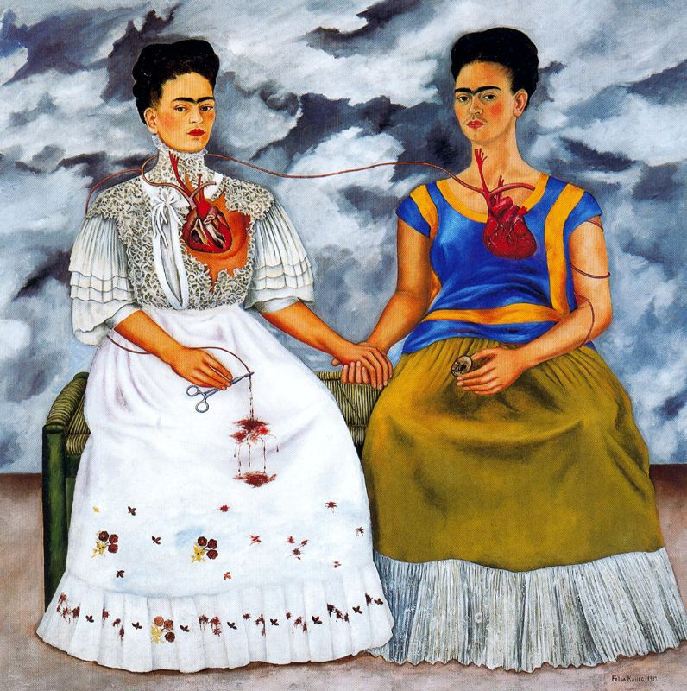Photos: Frida Kahlo, "Los Dos Fridas," 1939, oil on canvas

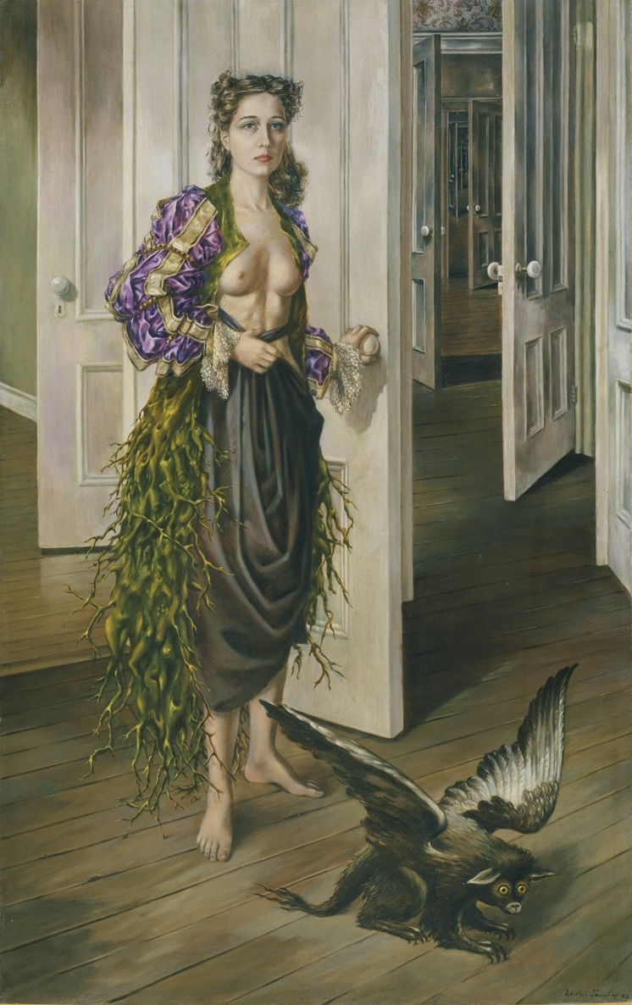 Dorothea Tanning, "Birthday," 1942, oil on canvas

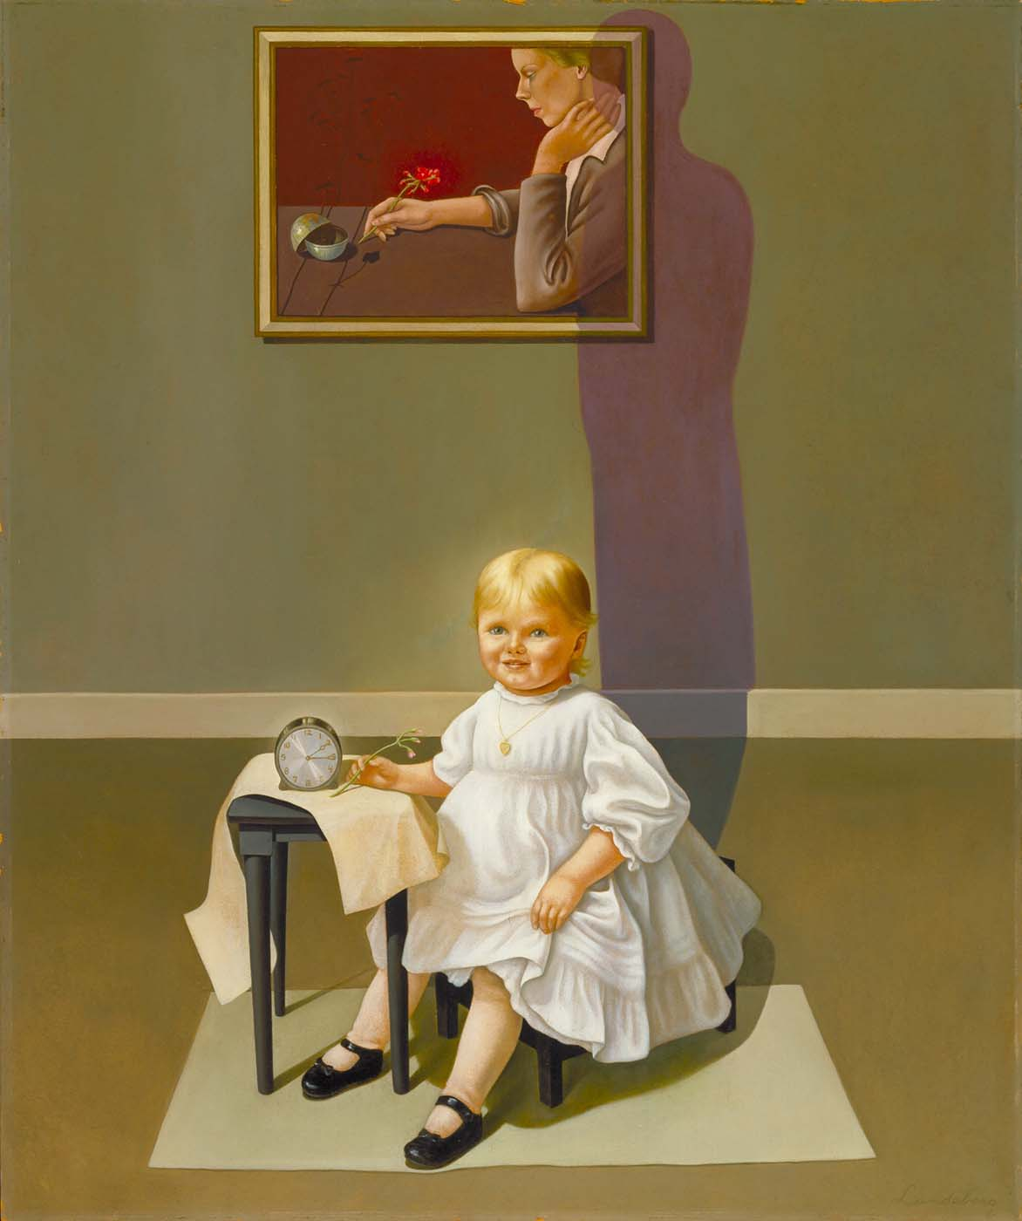
Helen Lundeberg, "Double Portrait of the Artist in Time," 1935, oil on canvas. Credit: Los Angeles County Museum of Art

