History of Design
Video Assignment: BBC Documentary: “The Allure of Art Nouveau” https://www.youtube.com/watch?v=6PHHhmLA8Sg
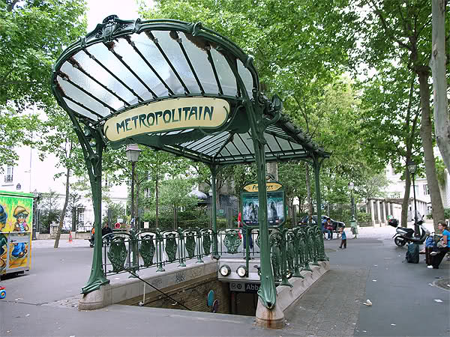entrance to Le Métro, designed by Hector Guimard
1. L’Art Nouveau (the new art) arose around 1895, at the fin de siècle (end of the century) in Paris, France. What was the fin de siècle like? What was happening?

2. How would you describe the Art Nouveau style? (Add to this list throughout the video):
- stylized forms
- use of both organic and industrial materials

3. Why was Le Metro created? Why is it “typically Art Nouveau”? (also discussed later, in section around minute 50)

4. Why was the International Exhibition (World Fair) of 1900 important for Art Nouveau?

5. Why was Montmartre (the neighborhood outside of the city center of Paris) important to the development of Art Nouveau? What was this neighborhood like?

6. What were some of the fin de siècle ideas about nature? (Pay attention to the section on Charles Baudelaire, the poet who wrote “Les fleurs du Mal” (Flowers of Evil) around minute 10. Also pay attention to the section about Darwin, etc. around minute 25.)
7. Why was the 1894/95 Gismonda poster (of the actress Sarah Bernhardt), by the Alphonse Mucha, important? What is the style like? Why did it create a sensation?

8. How would you describe Mucha’s “nouvelle” (new) woman?

9. How did Art Nouveau relate to the increased consumerism of the enlarged middle class? How did it relate to the upper class?

10. How did René Lalique change jewelry design?

11. Why were bats, butterflies, dragonflies, birds (often conflated with the figures of women) popular for Art Nouveau designers?

12. What was Émile Gallé (the glass artist) like? Generally speaking, what were some of his goals/contributions?

13. “The Dreyfus affair,” (relating to the officer Alfred Dreyfus), lasted from 1894-1906. Why was it significant?

14. How would you describe the visual style and the goals of the architect Hector Guimard?

15. Why did the Art Nouveau style decline in popularity?

