History of Design

Instructor: Gayle Clemans

Video: Frank Lloyd Wright and the Prairie School (57:00) http://digital.films.com/play/3QSPBW#
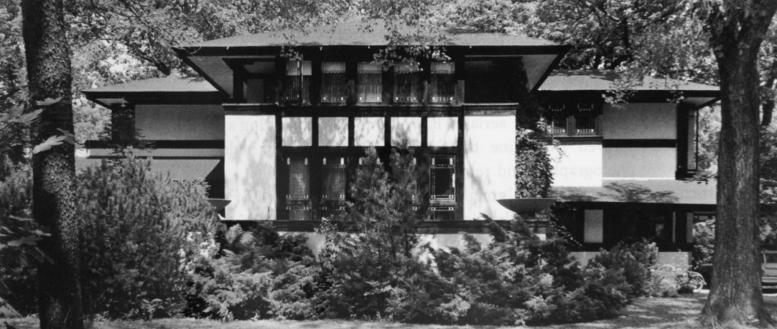
Frank Lloyd Wright, Ward Willits House, Illinois, 1900-1902

The Prairie School style is exemplified by the buildings of Frank Lloyd Wright and his associates. Watch this video about the origins of this style, which was inspired by the Arts and Crafts Movement, Louis Sullivan, and the Midwest.
1. How was Wright’s architecture influenced by the mid-West?

2. Why did this kind of architecture become known as “The Prairie School”? (This is also discussed towards the end of the video around minute 39.)

3. How did Wright feel about Victorian architecture? List a few of his evocative phrases used to describe the typical architecture of the time (and its architectural details)?

4. What did “organic architecture” mean? (And who said it before Wright?)

5. What did Wright learn from Louis Sullivan? How did Wright’s approach differ from Sullivan’s?

6. List key characteristics of Wright’s Prairie School houses (you should add to this list throughout the video). List elements related to: scale, orientation (vertical or horizontal?), materials, architectural features, interior lay-out, etc. Pay particular attention to the section that discusses Wright’s “new vocabulary for residential designs” and the Ward Willits house (around minute 23) and the section around minute 33.
- continuous windows
- deep overhangs

7. Other influences/interests: How did he feel about wood, Japanese architecture, music, the fireplace?

8. Why did his buildings appeal to certain kinds of clients? What kinds of people were they?

9. How did Wright and the Prairie School influence other architects or modern architecture in general?

